UUCSV Sermon June 4, 2023
“Our Faith is Love”
Sara Phinney Kelley

Part One: The UUA Responds with Love
UUA Responds to Growing Legislative Attacks Against Trans and Nonbinary+ Kids and the LGBTQIA+ Community, Statement released March 6, 2023
These are heartbreaking times. They are also defining times. An onslaught of oppressive laws and policies are threatening the lives and well-being of our children, young people and adults, our families, and the very fabric of communities.
We affirm and remain in solidarity with trans and nonbinary+ people because this is a fight for everyone’s humanity.
We are experiencing the outright political targeting of transgender and nonbinary+ children and adults, including the banning of gender affirming healthcare, bans against trans kids playing sports, and laws criminalizing drag. This policy violence and dehumanizing rhetoric creates an environment that can provoke physical violence and further discrimination. We are also witnessing efforts to criminalize reproductive healthcare, comprehensive education about race, Black history, and gender, and numerous issues of human rights that are spreading across countless states nationally. These attacks cut right to the heart of our fundamental religious belief in the inherent worth and dignity of each person, a fundamental right of conscience, and the values of personal agency that give us all the opportunity to live fully into our whole selves.
These issues of censoring education and the targeting of LGBTQIA+ communities and communities of color are not unrelated. They are intended to divide and make neighbor afraid of neighbor. They coincide with efforts to dismantle democracy and individual agency, all by pushing authoritarian policies that violate the sanctity of our homes, our bodies, and our diverse religious beliefs. As progressive people of faith, we recognize the forces feeding these far-right efforts. Throughout history, we’ve seen these tactics and ideology before and it always leads to destruction and violence.
However, Unitarian Universalism teaches a different way. We know we must create communities where all feel safe and all belong. Our faith calls us to show up powerfully - both pastorally, providing support and aid to our people and neighbors, and prophetically, with committed organizing and bold moral courage.
We are clear and unapologetic. Our LGBTQIA+ siblings are sacred, whole, and divine. As Unitarian Universalists, we understand that the full expression of the diversity of gender and sexuality is a gift. Our commitment to love and justice, to inclusive ministry and prophetic action, is deep and life-affirming. We actively organize to promote the leadership of Black, Indigenous, and people of color (BIPOC) communities. We work to end anti-Black racism, organize for racial justice, disability justice, gender justice, LGBTQIA+ equality, and support reproductive justice, climate justice and more.
Our hearts are with everyone in these frontline communities and states. Every day, we see a new regressive policy idea being introduced or debated. We pray especially for all our trans and nonbinary+ kids and their families and the communities supporting them. Trans and nonbinary+ people are living in an environment where legislators and policy makers are criminalizing their very existence. Trans children and their parents fear that the state will prevent them from receiving appropriate healthcare or from feeling secure in their families. It is forcing many people to consider relocating for their own safety and that of their families.
As progressive people of faith, we affirm and remain in solidarity with trans and nonbinary+ people because this is a fight for everyone’s humanity. We must actively work to create a society where trans children can be free to be who they are and fully live into their identity. And we must strengthen our partnerships across faith communities and with grassroots partners to build networks of safety and care while mobilizing for change that supports a more just, equal, and loving society.
Progress is not always constant or straightforward - and we will not succeed in opposing every bill targeted at our people and children. But we can find inspiration from our own Rev. Theodore Parker, who said in his sermon, “Of Justice and the Conscience” (PDF 11 pages), “I do not pretend to understand the moral universe, the arc is a long one, my eye reaches but little ways…But from what I see I am sure it bends towards justice.”
The Unitarian Universalist Association has continued to use both our voice and our actions to show up for trans and nonbinary+ youth and individuals. Visit the UPLIFT Action webpage of Side With Love to see the ongoing work to support our trans siblings and loved ones – and ways that you and your congregation can participate.
UPLIFT also sponsors monthly gatherings for trans and nonbinary+ people of all ages and we welcome any trans and nonbinary+ individuals in need of support and community to attend. Additionally, in the past year, we have spoken out unequivocally against anti-trans policies in Texas and Alabama and have supported legal actions challenging these dehumanizing laws.
We know that more must be done in our communities, congregations, and within the association itself to protect vulnerable people. We know that more is being asked of us - and more is needed from all of us to respond to this moment with clarity, compassion, and courage. And we know that we have the tools to create safe harbors, to continue to educate our children and communities about the full expression of human sexuality and gender, and the skills to organize to defend our values, our people, and the right of all people to be free and thrive.
We cannot do it alone. As UUs, we understand that we are part of the interdependent web of all creation. We belong to each other and this knowledge fuels our faithful commitment to unwaveringly fight for justice; to unwaveringly fight for each other.

Part Two: When Love is Missing
I originally thought about calling this service “From Outrage to Action”. So while I went with the theme of Love as the center of all we do as UUs, I’m still feeling the Outrage.
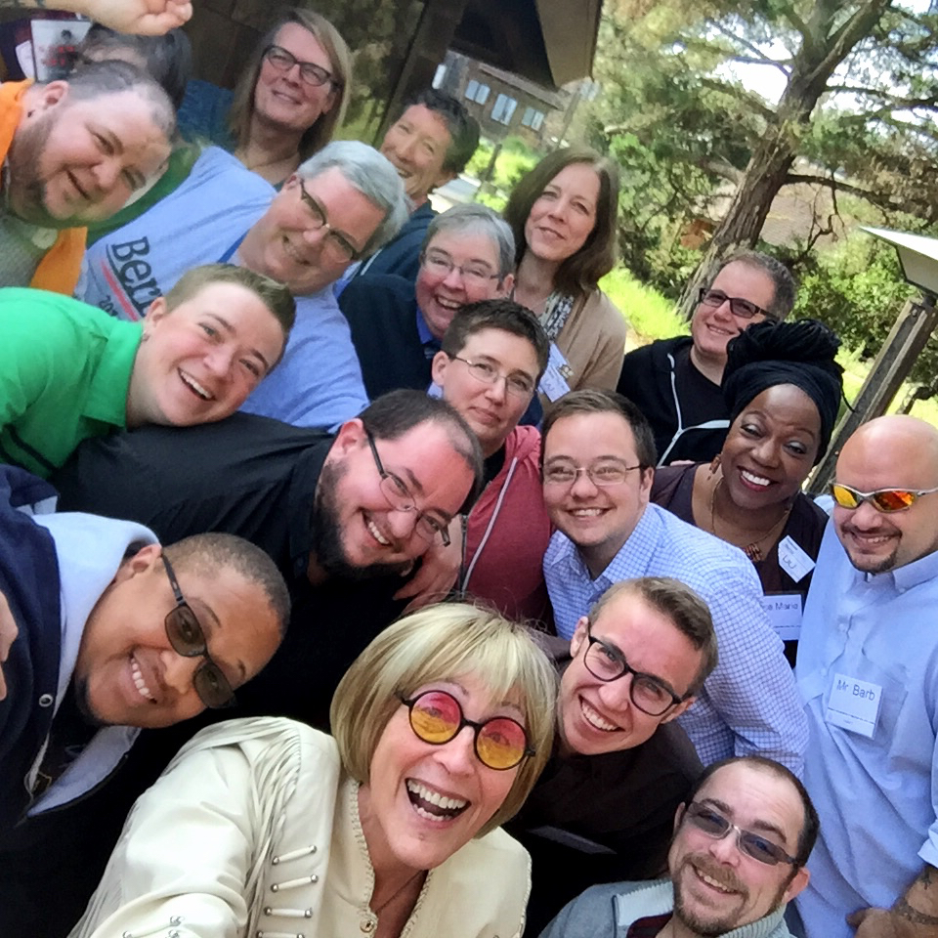
A 2018 survey by TRUUsT (Transgender Religious UUs Together – see anybody you know in this photo from their webpage? Yep, that’s Rev. DC!) reported that transgender and nonbinary UUs are feeling unwelcome in what many of us must think are safe, supportive spaces. These two slides are just a few shared in a webinar from Side With Love and Uplift recently, by Adrian Ballou of the Uplift office (that’s their face in the upper right). It reminds us that we have work to do in our own congregations!

But the outrage has just grown bigger and more insistent. All you have to do is watch or read the news. It’s not just the anti-LGBTQ+ violence that is increasing – tripling since last year. It’s more systemic than that. You heard much of this in the UUA press release.

As of this week, there have been 467 anti-trans, anti-LGBTQ+, anti-drag bills introduced in legislatures around the country. Four hundred sixty seven. That’s an average of more than NINE per state, and you know they’re not evenly distributed.

Erin Reed, on their website Erin in the Morning, tracks anti-trans legislation around the country. This is what the landscape looked like last December. The dark red are the worst laws, medium red are high risk, light red are moderate risk. Pennsylvania is a light blue state, meaning low risk, and the darker blue are the safest states with protections for trans people. Take a look at this map and see how safe trans and nonbinary people felt at Christmas.
Now look at the May 2023 map. Florida is now black with a Do Not Travel there warning. As of this morning, it’s likely that Texas would also be black. And see how much more dark red and medium red states there are? Look where Pennsylvania lies now – right up against the threat. And yes, it is a threat, and why I am outraged.

What do these bills really do? Not what the sponsors say they will do, which is protect parental rights and recognize what we all know, that everybody’s inside matches their outside, right? No, what they’ll really result in is:
- increased lack of health care access at all levels, not just for children and youth but also for adults. I know a trans woman who can’t get her medication right now. In New York.
- increased suicidal ideation and actual suicide. Remember Zooey Zephyr, the representative from Montana who got banished from the house floor when claiming their anti-trans bill would leave legislators with blood on their hands? That’s what Rep. Zephyr was talking about.
- Some families are having to separate so their children can access health care. Even temporarily, that is not a family-friendly policy.
- Other families are now worried enough that they feel they need to move. As early as late March, UUA field staff across the south were already getting calls about where families of trans people could go.

Our former affiliate minister, Rev. Kristina Spaude, is at a church in Florida – and she has families asking for resources.

Rev. DC has a friend and colleague in Florida who is themselves trans. They no longer feel comfortable where they live. So they are leaving their church in Florida, hoping to find a placement in a state where they will feel safe.

And they told Rev. DC a story of a young person who got kicked out of their house for being trans. A UU minister in their town in south Florida invited them to lunch. Turns out a colleague from the next UU church north also just happened to come to lunch. The young person said they were going to that minister’s town, too, and could they have a ride? At the next stop, it happened again. And that young person made it all the way to Atlanta with the help of an informal UU ministry network. None of the adults ever asked if they could give a ride or other help, so to avoid any semblance of abuse. But they created the space for this young person to get what they needed. An underground network.

And these won’t be the only stories we hear this summer and fall from UUs or anyone else, particularly the parents of trans kids. That’s outrageous.
Part Three: How Do We Show Love?
So what can we do about it, other than just feeling outraged?

We’re learning, which is a good start. We might consider paying for a six-week online program from the Transforming Hearts Collective, which is co-directed by Rev. DC’s good friend Alex Kapitan. It’s a program that works with individuals and congregations to teach us how to be fully inclusive, and truly be a safe space for trans, non-binary, and any LGBTQ+ people. We could do it ourselves, or join in with other central PA congregations to offer it. I know of several congregations who have done it and say it’s life-changing.

Step two - We can help enormously just by letting know that our trans friends and family are SEEN. In this Pride month, lots of people wear rainbow stuff, but it’s hard for a trans person to wear the pink, white, and blue because it can make a person a target for hate in many forms. So continue to patronize businesses that support Pride such as Target, or, say, the Lewisburg Starbucks, which is happily decorated for Pride month (by two high school students).

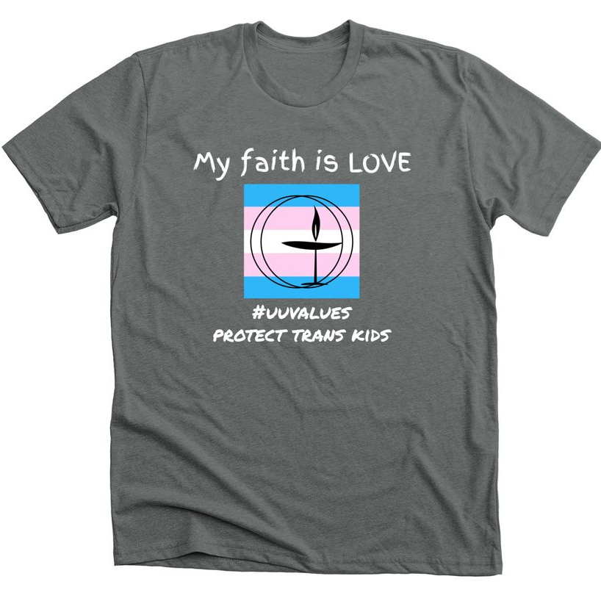
And buy these t-shirts or sweatshirts from TransUUs of Florida. They were created by my colleague Jess Hunt, who is the mother of a trans kid. And worried and motivated. And worried. Support Jess’s work and wear these as an ally. Those of us who are cisgender have less to worry about if we do, and then not only is the message seen, but it means that trans folx who see us know they are seen, too.

Rev. Elizabeth Mount is the minister at the UU congregation in Cheyenne, Wyoming, a pretty hostile state. They suggest supporting UU Youth and adults in states that are most at risk. Send postcards of support. Send chocolate! Send rocks that people can use for fidgeting during hard times. They tell a story of ordering holiday ornaments in various LGBTQ+ colors for the church tree. When the company – in Colorado Springs, no less – heard what ornaments they were for, they doubled the order. And the youth in Elizabeth’s church were thrilled to see themselves represented.

Step three is to make ourselves HEARD. Show others what encompassing love can look like. Sure, wear your t-shirt in public. But think about joining UU Justice PA and doing what they ask of us, including calling and writing legislators – even though most of ours won’t agree, we need to keep pushing – and showing up sometimes in Harrisburg. We are close enough to do that, most of us.

We can write letters to the editor. I heard recently of the state UU action group in North Carolina giving a one-hour virtual training in how to write a letter to the editor – and by the end of one hour every participant had one ready to go. We have really good writers here who might help.

But then there’s a big ask, for those who want to do more to show love, and those who can do more. That’s not all of us, I know. But what about things like:
- Providing affordable housing for families who have to move to get care for their kids
- Providing funds for affordable housing for families who may have to leave jobs and start over for their family’s safety
- Helping with hiring and job seeking if there’s a family coming to our area
- Identifying medical professionals who will work with trans and nonbinary folx and families

Anyone want to work on a resource list with me? I’m sure there are partners in the area, many headed up by people who have been associated with this congregation. It might have to be quiet for a while, given how dangerous exposure could be for the people we are supporting. But that might be a risk worth taking.

Oh, yeah, and how do we support our own minister? We want him to stay. Let’s make sure that can happen, too.

What brought it all home to me were the stories. Not only the ones I told earlier, but also this week hearing from a minister who is trans and disabled in Oklahoma, and needing to move for their own safety and their family’s safety. They spoke at a Zoom meeting I attended this week: “Those of us who move through the world with no risk have safety for ourselves and our families.”

What can we do to make our community, their community, the world, safer for those who don’t move as easily through the world we live in? How do we show love?

